
NAME : BISMA FATIMA
CLASS : CS A
ROLL NO: F24605036
COURSE : COMPUTER NETWORK
COURSE CODE : CS-271
LECTURER : SIR NAVEED YOUSAF

LAB 10

Configuration of ACLs

Warm-up Task [30 Minutes]
- Answer each question in your own words (3 to 4 lines)
1. What is an Access Control List (ACL)?
An ACL is a set of rules applied to routers or switches to filter network traffic. It decides whether packets are allowed or denied based on IP addresses, protocols, or ports. ACLs help enforce security and manage traffic flow.
2. Differentiate between Standard ACL and Extended ACL.
- Standard ACL filters traffic only by source IP address.
- Extended ACL filters by source and destination IP, protocol type, and port numbers. Extended ACLs provide more precise and flexible control compared to standard ACLs.
3. How are ACLs processed in a router?
Routers process ACLs sequentially from top to bottom. Each packet is checked against the rules until a match is found, then the action (permit or deny) is applied. If no rule matches, the packet is denied by default.
4. What is the wildcard mask in ACLs?
A wildcard mask defines which bits of an IP address must match in ACL rules. A 0 means the bit must match exactly, while a 1 means it can be ignored. This allows ACLs to match ranges of IP addresses flexibly.
5. How does an ACL differ from a Firewall?
An ACL is a basic traffic filter applied at the router level, controlling access based on simple rules. A firewall is more advanced, offering deep packet inspection, stateful filtering, and protection against threats. Firewalls provide broader security, while ACLs focus mainly on traffic control.
6. What are Inbound ACL and Outbound ACL?
- Inbound ACL filters packets as they enter a router interface before routing decisions.
- Outbound ACL filters packets after routing decisions, as they leave the router interface. This distinction helps control traffic direction effectively.
7. What is the purpose of an ACL in the context of network security?
ACLs enforce security policies by controlling which users or devices can access network resources. They prevent unauthorized access, reduce unnecessary traffic, and protect sensitive data. In short, ACLs act as a gatekeeper for network communication.

In Lab Task
By using Drag and Drop draw the topology diagram as Shown below and attach a screenshot of each step.

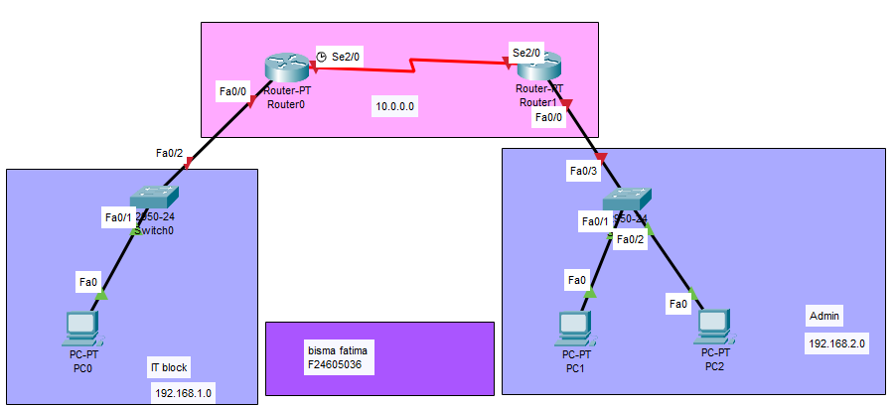

Figure 1. Packet Tracer Topology Diagram

Configuration of ACL Steps

Step 1: Draw the Topology (Drag and Drop)
- Open Cisco Packet Tracer.
- Drag and drop the following devices:
  - Routers (at least 2, depending on your diagram).
  - Switches (one per network block).
  - PCs (for Admin Block, Student Block, etc.).
- Connect them using appropriate cables (straight-through for PC–Switch, crossover for Router–Router if needed).
- Label each block (Admin, Student, etc.) for clarity.
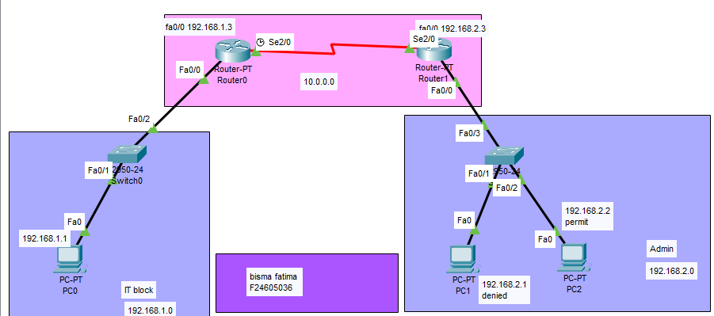
Step 2: Assign IP Addresses
- On each PC:
  - Go to Desktop → IP Configuration.
  - Assign IP addresses and subnet masks according to your design.
- On each Router:
  - Enter CLI and configure interfaces:
- Router> enable
- Router# configure terminal
- Router(config)# interface fa0/0
- Router(config-if)# ip address 192.168.1.1 255.255.255.0
- Router(config-if)# no shutdown
- Repeat for all interfaces.
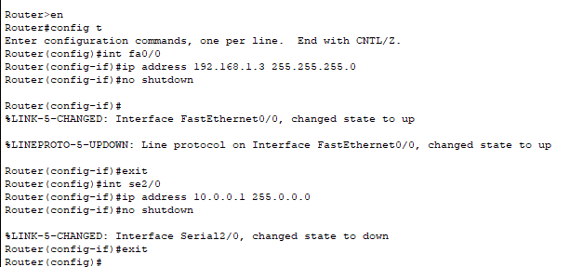
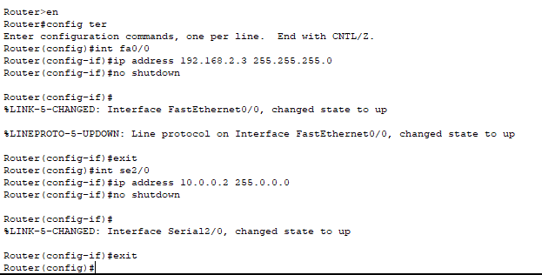

Step 3: Configure RIP (Routing Information Protocol)
- On each router:
- Router(config)# router rip
- Router(config-router)# version 2
- Router(config-router)# network 192.168.1.0
- Router(config-router)# network 192.168.2.0
- Router(config-router)# network 10.0.0.0

- Add all connected networks.
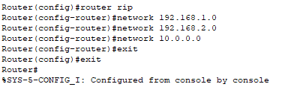
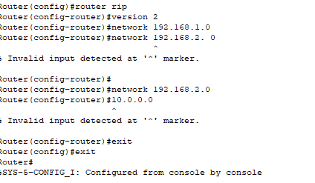
- Verify with show ip route.
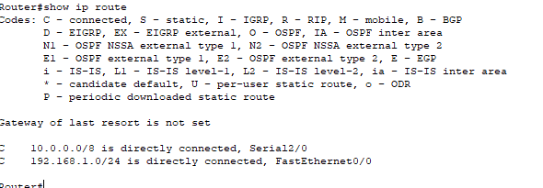
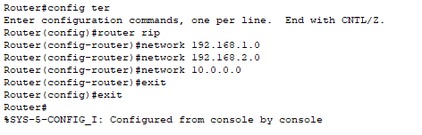

Step 4: Verify Communication
- Use Simulation Mode in Packet Tracer.
- Ping from one PC in the Admin Block to another PC in the Student Block.
- Successful communication shows green checkmarks.

Step 5: Apply Standard ACL
- Use your NUTECH ID’s last two digits as the ACL number. Example: if ID ends with 36:
- Router(config)# access-list 36 deny 192.168.1.10
- Router(config)# access-list 36 permit 192.168.1.20
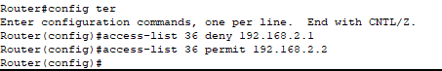
- Apply ACL to the interface:
- Router(config)# interface fa0/0
- Router(config-if)# ip access-group 36 in
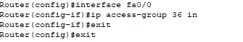
- Test by pinging:
  - From the denied IP → ping should fail.
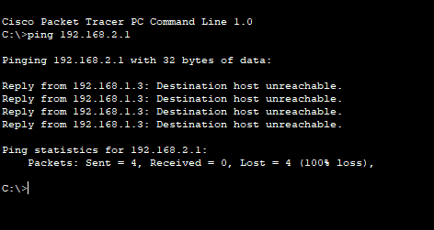
  - From the permitted IP → ping should succeed.
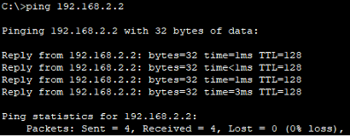

Post Lab Task
By using Drag and Drop draw the topology diagram as Shown below and attach screenshot of each step.

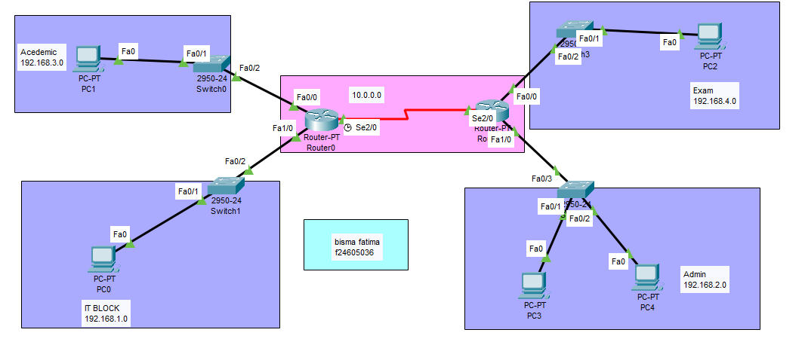
Instructions:
- Highlight different sections.
- ACL number will be your Nutech ID's last two digits.
- Divide the given topology into four different networks.
- IT Block can communicate with every other Block.
- No Block Can communicate with IT Block except Admin Block’s One IP Address.
- Academic Block can communicate only with Exam Block.
- Exam Block can communicate only with Academic Block and One IP Address of Admin Block.
- Send packets (Real time).
- Send packets (Simulation).

- Take screenshots of every step

Router configuration:

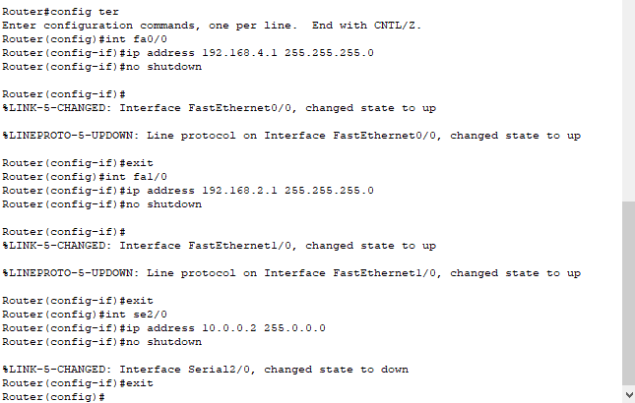

Router rip
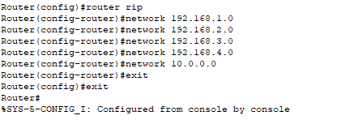

Show ip route:
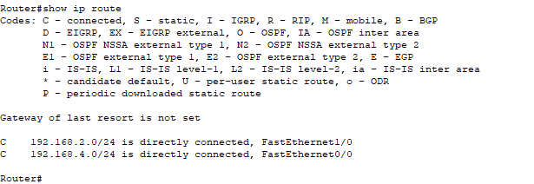

Real time before ACL:
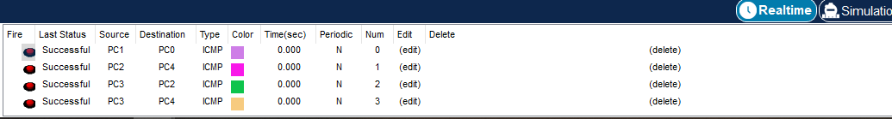

ACL config for router 0:

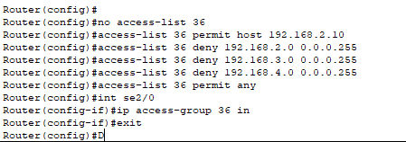
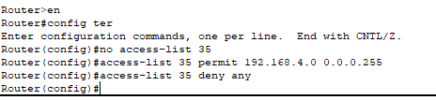
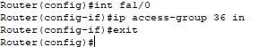

ACL config for router 1:

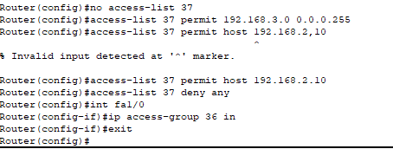

Real time :

